**SYSTEM ARCHITECTURE**

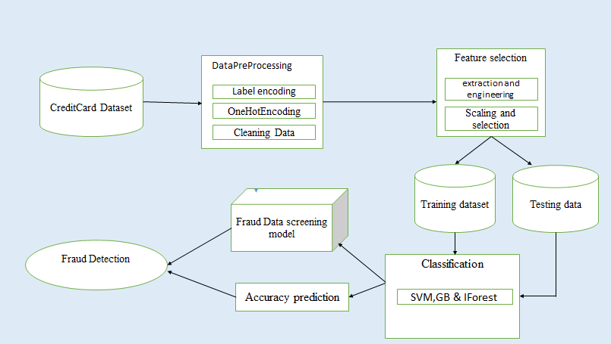

**UML DIAGRAMS**

**USE CASE DIAGRAM**

A use case is a set of scenarios that describing an interaction between a user and a system. A use case diagram displays the relationship among actors and use cases. The two main components of a use case diagram are use cases and actors. An actor is represents a user or another system that will interact with the system modeled. A use case is an external view of the system that represents some action the user might perform in order to complete a task.

CreditCard Dataset

Pre-Processing

Feature Extraction

Classification

SVM, GB & IForest

Prediction

Prediction

User

End

**ACTIVITY DIAGRAM**

Activity diagrams are graphical representations of workflows of stepwise activities and actions with support for choice, iteration and concurrency. In the Unified Modeling Language, activity diagrams can be used to describe the business and operational step-by-step workflow of components in a system. An activity diagram shows the overall flow of control.

CreditCard Dataset

Pre-Processing

Feature Extraction

Classification

Output

**SEQUENCE DIAGRAM**

A sequence diagram in Unified Modeling Language (UML) is a kind of interaction diagram that shows how processes operate with one another and in what order. It is a construct of a Message Sequence Chart. Sequence diagrams are sometimes called Event-trace diagrams, event scenarios, and timing diagrams.

A sequence diagram shows, as parallel vertical lines (lifelines), different processes or objects that live simultaneously, and, as horizontal arrows, the messages exchanged between them, in the order in which they occur. This allows the specification of simple runtime scenarios in a graphical manner.

user : user

user : user

CreditCard Dataset

Cloud service

Provider

Feature Extraction

TreeStcture

Classification

Search

Output

Dataset Collect

Pre-Processing

Data Splitting

Training & Testing

SVM, GB & IForest

Analysis

Classification

Fraud Detection

Result

**COLLABRATION DIAGRAM**

Collaboration diagrams belong to a group of UML diagrams called Interaction Diagrams. Collaboration diagrams, like Sequence Diagrams, show how objects interact over the course of time. However, instead of showing the sequence of events by the layout on the diagram, collaboration diagrams show the sequence by numbering the messages on the diagram. This makes it easier to show how the objects are linked together, but harder to see the sequence at a glance.

user : user

Dataset

CreditCard Dataset

Pre-process

New Data

1: Train

2: Test

3: Data Split

4: Training & Testing

5: Feature Extraction

6: Classification

7: Fraud Detection

8: Output

9: Prediction

**Data Collection**

the outer overall functionality of the proposed system application this indicates that have collected the creditcard dataset from various source and analysis and processing of data have done by predicting the farmland and classifying the rate of accuracy from this information by plotting the graph creditcard fraud is predicted.

**Pre-Processing**

The data is cleaned before loading to the Classifier. Import the Label Encoder class from the sclera library, fit and transform the first column of the data, and then replace the existing text data with the new encoded data.One hot encoding is a process by which categorical variables are converted into a form that could be provided to ML algorithms to do a better job in prediction. This work fitting and transforming StandardScaler method on train data.

FEATURE EXTRACTION

The Feature extraction by Layering of data. For feature extraction, first select the data and process data for original feature. Then reduce the feature by transform refining data. This can be done by selecting the data by CSV file and process the data for original feature and it was transformed and refining data to reduced feature, finally it predicts the accuracy of CreditCard.

SPLITTING DATA

The Splitting data by two ways are Training dataset and Testing dataset. In statistics and machine learning we usually split our data into two subsets: training data and testing data (and sometimes to three: train, validate and test), and fit our model on the train data, in order to make predictions on the test data. When this work do that, one of two thing might happen: we overfit our model or we underfit our model. It don’t want any of these things to happen, because they affect the predictability of our model — Work might be using a model that has lower accuracy and/or is ungeneralized .

**CLASSIFICATION**

Classification of data through IForest (Isolation Forest) Algorithm use randomness by design to ensure they effectively learn the function being approximated for the problem. Randomness is used because this class of machine learning algorithm performs better with it than without.The most common form of randomness used in neural networks is the random initialization of the network weights. A iforest with a certain level of complexity, a network with more than two layers. IForest use sophisticated mathematical modeling to process data in complex ways. Each layer performs specific types of sorting and ordering in a process that some refer to as “feature hierarchy.”

**ACCURACY PREDICTION**

The accuracy agriculture prediction occurs using the classifier, list with predicted values and plot the farmland graph. Predicting the test set result. The prediction result will give you probability of finding the farmland. This will convert that probability into binary 0 and 1. 1 for Fraud and 0 for Non-Fraud. This is the final step where this work evaluating our model performance. It predicts the Confusion matrix to check the accuracy of model.